

**YAŞAR UNIVERSITY**

**FACULTY OF ENGINEERING**

**DEPARTMENT OF INDUSTRIAL ENGINEERING**

**IE 4910 SYSTEM ANALYSIS REPORT**

**A Warehouse Management Decision Support System for TOTOMAK**

Burak Kurt, Güner Şirin, Melis Karakurt, Sevde Zümrüt İspay

**Academic Advisors**

Prof. Dr. Levent Kandiller, Res.Asst. Simge Güçlükol

**Company Advisors**

İrem Amaç, Doğuş Özbaş

**Izmir, 2023**

***Abstract***

**Warehouse management is considered as one of the essential components of a supply chain. Inadequate storage space and inefficient available storage are common problems in designing warehouses. In this project, an effective warehouse management policy is needed because of having limited space for finished goods. The complementary solution is to ensure that the highest-selling inventory is easily accessible by placing it at the most accessible point. Position of the finished goods and deciding the sequence of routes to perform the fastest loading and unloading work are critical factors in reaching maximum efficiency. This project aims to provide easy access to stored goods and minimize the travel time between the picking and the placing positions to avoid inefficient routes and disruptions by strategically planning the warehouse layout design and running each operation in the best sequential manner.**

***Keywords***— **warehouse management, ABC analysis, quadratic assignment problem, assignment problem**

1. Introduction

This project was processed with Totomak Machinery and Spare Parts Company which specializes in producing special machinery and spare parts. Totomak is export-oriented and makes 95% of its sales abroad. In this project, warehouse management will be considered for this company. Warehouse management involves the systematic organization and control of storage and shipping operations within a company to optimize efficiency, reduce costs, and increase revenue. This includes tracking and management of inventory levels, integration of products and processes, and the implementation of strategies to streamline operations. Companies can manage their supply chain and ensure that their products are available and shipped in a timely and cost-effective manner by effectively managing their warehouse. Warehouse management systems are one of the integral components of supply chain management, serving to regulate the storage and movement of materials within a warehouse. These systems provide a range of benefits, including improved inventory control, increased efficiency and productivity, and reduced costs (Leong & Ee, 2012). They do not have a specific policy to pick and place products on shelves, so they want to apply the "First in, First out" (FIFO) policy. To understand the current system, the company is analysed in detail in the 'Macro Analysis' part, then the data from previous years were analysed and explained in the "Micro Analysis" part of the report. The reasons for the problem are searched in the 'Problem Definition' part. A literature survey is made to decide which methods should be used in the Overview of Solution Procedures and Book Level Literature Review part. According to all these steps, the solution method is determined as a quadratic assignment problem approach and assignment problem models as mentioned in the 'Modelling Approach' part of this study.

1. Macro analysıs

Totomak was founded in 1950 as a small workshop in Cankaya, Izmir. In 1960, the factory was moved to Alsancak, Izmir, and began producing drilling and carpentry machinery, hydraulic jacks, and cylinder sleeves. Also, Totomak started selling OEM parts to Turkey's first truck manufacturer here. After long years, the factory position became a problem because of urbanization. Therefore, the factory was relocated to AOSB Cigli, Izmir, in 1990. Totomak began exporting its products in a new factory and achieved its target of exporting 85% of its products in eight years. As a result of this considerable growth, the company bought and constructed a new factory building as an expansion area and reached a total area of 23.000 $m^{2}$ in 2007. The company decided to grow more and founded its second factory in Monterrey, Mexico, in 2010 as a foreign activity. It was a reasonable investment since it is a manufacturing company with a strong export focus. Lastly, Totomak MX expanded its closed area and decided to establish the Batı Isıl Mexico Heat Treatment Plant in 2017, which began serial production in April 2018.

Over the years, Totomak became a company with a 95% export ratio, which is the company exporting nearly all its products to North America, Western Europe, Asia, and South America. It is a leader in product groups in its industries. The primary target of Totomak is to satisfy its business partners' expectations in terms of cost-delivery quality and become the most preferable and competitive manufacturing supplier in the business areas in that they operate with the help of machining experience and R&D organizations. Totomak's workforce comprises Turkish and Mexican workers, totalling 880 employees. The company's strong international presence and dedicated workforce make it a leader in the manufacturing industry.

Since its foundation, Totomak started to receive essential certificates: ISO 9001 Quality System Certification, ISO 16949 Quality System Certification, ISO 14000 and OHSAS 18001 Quality System Certifications, ISO 27001:2013 Information Security Management System Certification.

Table I.  
Yearly Sales

|  |  |
| --- | --- |
| **Year** | **Million (€)** |
| 2017 | 20 |
| 2018 | 20 |
| 2019 | 20 |
| 2020 | 19 |
| 2021 | 21 |
| 2022 | 27 |

The company made sales of 20 million euros in 2017-2018-2019. Although there was a decline in sales in 2020 with the effect of the pandemic, the pandemic experienced a rapid recovery in the next period and reached the highest sales number in 2022.

Table II.  
Materıal Consumptıon

|  |  |  |  |  |
| --- | --- | --- | --- | --- |
| **MATERIAL** | **TYPE/FORM** | **ANNUAL CONSUMPTION (tons)** | | |
| **Totomak TR** | **Totomak MX** | **TOTAL** |
| GRAY/DUCTILE CAST IRON | CASTING | 13.000 |  | 13.000 |
| LONG STEEL | BAR | 5.000 | 6.000 | 11.000 |
| ALUMINUM | CASTING | 250 |  | 250 |
| STEEL ALLOYS | FORGING | 3.500 | 2.000 | 5.500 |
| STEEL ALLOYS | STAMPED |  |  |  |

|  |  |  |  |
| --- | --- | --- | --- |
| **TOTAL** | 21.750 | 8.000 | 29.750 |

Raw materials are used by the company shown in **Table II**. The company uses 29750 tons of raw materials annually. 13000 tones of these are gray/ductile cast iron for the casting process, 11000 tones are long steel for the bar process, 250 tones are aluminium for the casting process. 5500 tons of steel alloy for the forging process.

Materials are cut or shaped using machine tools in machining processes, such as sawing, turning, and milling. Milling can be performed in vertical and horizontal orientations, and grinding can be performed using various techniques, such as center grinding, centerless grinding, surface grinding, and eccentric crank grinding. Gun drilling and micro-finishing are specialized processes used to create deep holes and refine surfaces to a high degree of precision. Deburring and vibrogrinding involve removing burrs and using vibratory motion to assist in grinding, respectively. Balancing, which involves adjusting the weight distribution of a rotating object to reduce vibration, can be performed in both vertical and horizontal orientations. Hobbing, honing, and lapping involve cutting gears, refining surfaces, and achieving a polished finish. High-pressure washing is a process that uses high-pressure jets of water to clean the surface of a workpiece.

Totamak has various Assembly and Test Lines, as listed below:

* Oil Pump Assembly Line
* IGM (Integrated Gas Module) Assembly Line & Test Machine
* DCM (Diesel Conduct Manifold) Assembly Line & Test Machine
* TSM (Test Selected Manifold) Assembly Line & Test Machine
* Drums
* Knuckles
* King Pins
* Flywheels
* Distributors
* Crank Cases

Climatization

Energy

Heavy Duty Machining

Automative

* Adapters
* Rings
* Valve Plates
* Engine Connection
* Blocks
* Bolts
* Crank shafts
* Housings
* Fittings
* Cover Plates
* VariousDrive Components
* Integrated Gas Modules
* Manifolds

Figure 1. Sector Distribution

1. Mıcro analysıs

In this context, required data for project analysis, such as the list of shipped materials, demand list, warehouse layout, and square measure, is received from Totomak. Based on the data we obtained from the company, we used ABC analysis, Pareto analysis, quadratic assignment problem analysis, and assignment problem methods to understand and diagnose the company's problems in terms of warehouse management.

**Figures 2,3,4** show that ABC Analysis is applied to find the most important products which are needed to be placed on accessible shelves. Products are categorized by their sales weights, and the products with high frequency are defined as group A, constituting 50% of the orders.

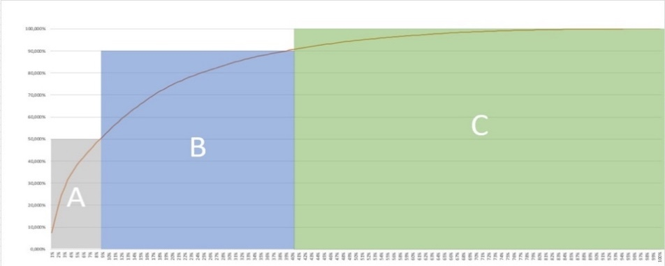

Figure 2. ABC Analysis 2023 for Sales

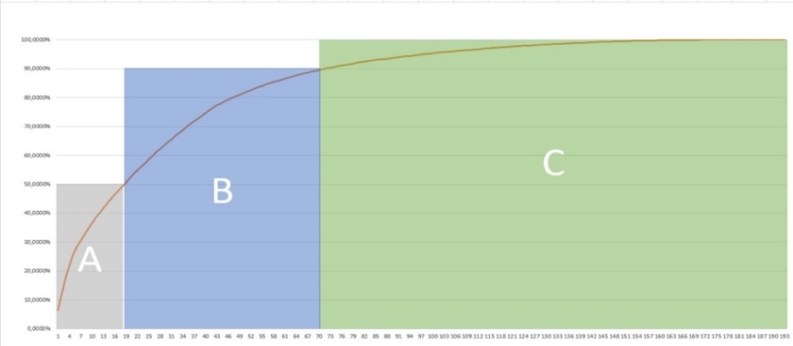

Figure 3. ABC Analysis 2022 for Sales

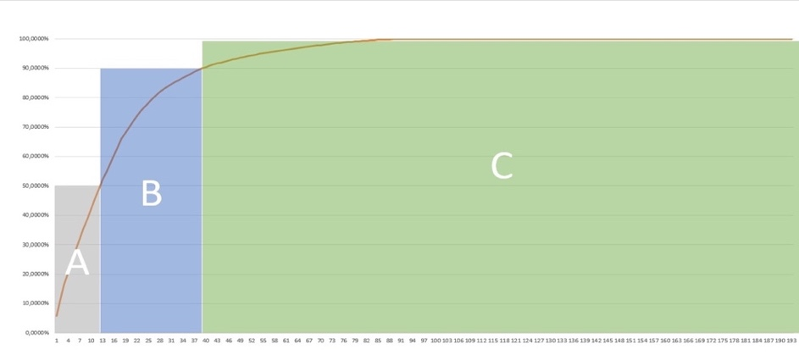

Figure 4. ABC Analysis 2021 for Sales

In the orders for the year 2023, group A consists of 16 products, with product codes X56, X132, X50, X150, X127, X168, X70, X66, X67, X115, X187, X47, X46, X90, X3, and X11, in order of frequency. These products make up 50% of the orders in 2023. Group B consists of 58 different products, and group C consists of 114 products. The remaining five products are unrecorded orders.

In 2022, group A consists of 18 products, with product codes X50, X56, X150, X132, X55, X66, X145, X67, X115, X187, X125, X80, X168, X121, X155, X186, X47, and X136, in order of frequency. Group B consists of 45 products, and group C consists of 104 products. The remaining 18 products are unrecorded orders.

In 2021, the company's sales were halved due to the impact of the coronavirus pandemic. Therefore, group A consisted of 12 products, with product codes X45, X137, X11, X98, X125, X182, X46, X121, X187, X183, X101, and X2, in order of frequency. Group B consisted of 27 products, and group C consisted of 57 products. The number of unrecorded orders was 97 products, which shows the damage the pandemic caused to the production sector.

In our Pareto analysis, we used the 80-20 rule, also known as the Pareto principle, as a basis for our work. This principle states that, for many events, roughly 80% of the effects come from 20% of the causes. Our analysis of the company's sales data revealed that 48 products accounted for 80% of the total quantity, and 140 products accounted for only 20% of the total quantity. On the other hand, five products did not contribute to the total. Based on this information, we were able to identify the key factors that were contributing to the warehouse management problem and develop a solution that focused on addressing these underlying causes. By utilizing the Pareto principle and focusing on the most impactful factors, we were able to come up with a more effective solution for the warehouse management issue.

Studies in ABC analysis were verified using with Pareto analysis.

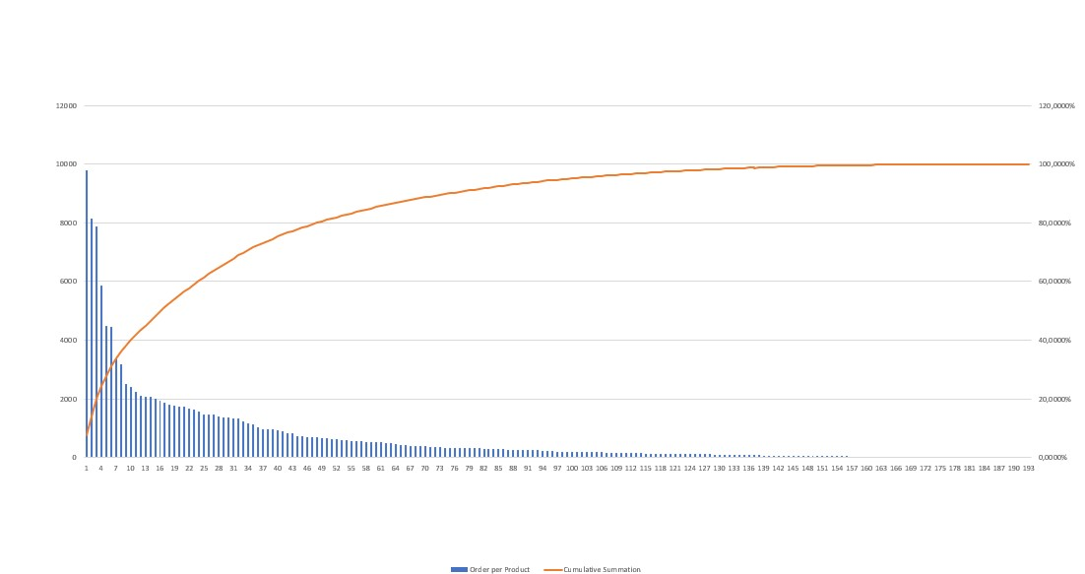

Figure 5. Pareto Analysis 2023 for Sales

Our analysis of the company's sales data in 2022 showed that 80% of the total sales were generated by 47 products. The remaining 20% of sales were contributed by 128 products, while 18 did not have any sales.

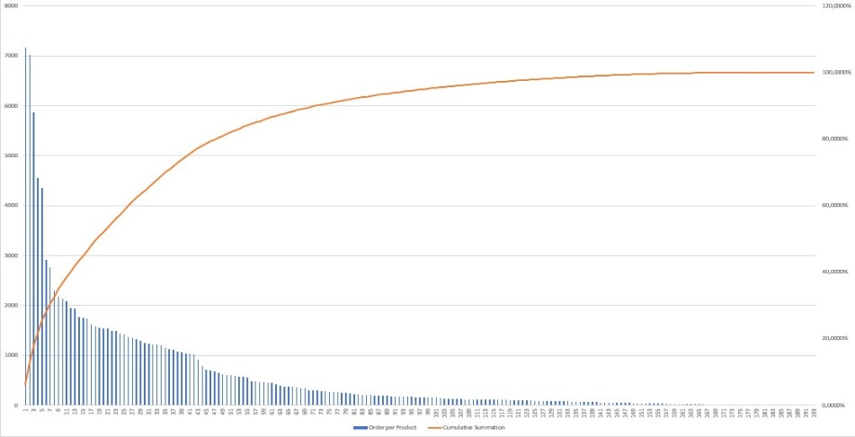

Figure 6. ABC Analysis 2022 for Sales

In 2021, the company's sales were significantly impacted by the COVID-19 pandemic. As a result, we conducted a Pareto analysis to identify the key factors contributing to the decline in sales. Our analysis showed that 26 products accounted for 80% of the total sales, while the remaining 71 products accounted for 20% of sales. Furthermore, there were 96 products for which there were no records of orders, indicating the significant impact of the pandemic on the company's sales.

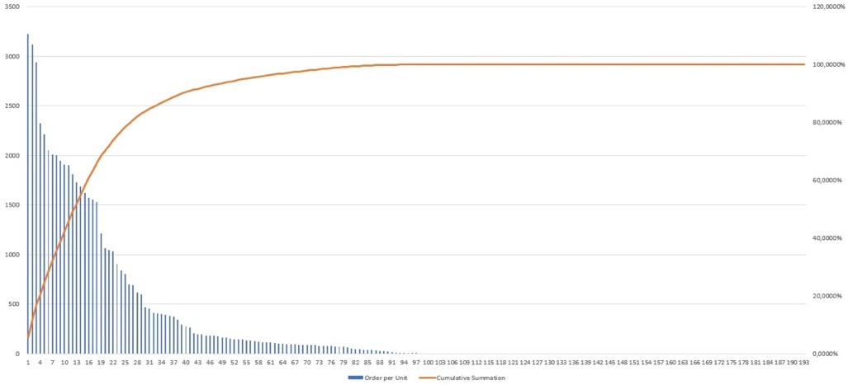

Figure 7. ABC Analysis 2021 for Sales

In conclusion, in Pareto analysis, we attempted to analyse our data using the 80-20 rule to identify products with high sales frequency. Due to the pandemic of 2021, there were significant differences between the results of our 3-year data analysis and 2-year data analysis. Therefore, in our studies, we based our findings on data from 2022-2023, which led us to more satisfactory results. As a result of the examinations, the definition of the problem emerged, and solution methods were started to be developed.

Figure 8. Warehouse Layout

Nowadays, the company is moving to a new warehouse. It is considered that moving to a larger warehouse instead of the current warehouse. The layout of the new warehouse is shown in **Figure** **8**. warehouse 4 will not be used. The company thinks of it as a waste dump. It is developed that work in the main warehouse. Which is divided into 3 parts. Warehouse 1 is generated with the production line, Warehouse 2 is the main part of the warehouse. Warehouse 3 is the delivery part. The company is planning to make the shelf system like a cross array or H shape array in the warehouse.

1. Problem defınıtıon

Due to the inadequacy of its production warehouse in Izmir, the company will be moving to a new warehouse this year. The inadequacy of the warehouse has caused the FIFO principle not to be implemented and some products to be left in the warehouse for longer than necessary because these cause additional holding costs, the uncertainty of demand fluctuations, and production disruption, which in turn causes financial losses for the company.

The project aims to reduce the unnecessary time and number of forklift operations required for warehouse entry and exit, in addition to FIFO, to increase the company's warehouse management efficiency.

The company has a complex system, and the forklifts are wasted time. The waste of time is for the employees as well as the forklifts. The challenge is figuring out where and how to put incoming products in the warehouse and removing outgoing products after carefully inspecting the warehouse's layout. This project aims to increase the efficiency of the company's warehouse management by reducing the time and number of unnecessary forklift operations required at the warehouse entrance and exit. At this point, we will determine an algorithm for the pick-place application of products after product assignment.

While the system was observed, a fishbone diagram is created. It is also known that weekly production and shipping plans are available, and predictions can be made about the entry and exit of products in the warehouse in the coming days. The subcategories of the reasons put forward to solve the problem are given.

* Our reasons for the "Data availability for analysis" section of our diagram are that the collected data is either not stored in an easy format or is not accessible and some necessary data is not collected.
* Company has the "Pick and place operations" issue because pick and place operations are not scheduled and there are work safety problems.
* Since there is "No policy for picking like FIFO", the random entry and exit of products cannot be tracked, and it may cause the products to remain in stock for a long time and become deformed.
* Due to "Unknown SKU locations", products cannot be easily accessed, SKU locations cannot be tracked, and cause limited space usage.
* Also, there is "Manual Routing by the forklift operator", extra transportation time arises and there is a redundant forklift movement.

The reasons suggested for the solution to the problem and their subcategories are given in the fishbone diagram in **Figure 9**.

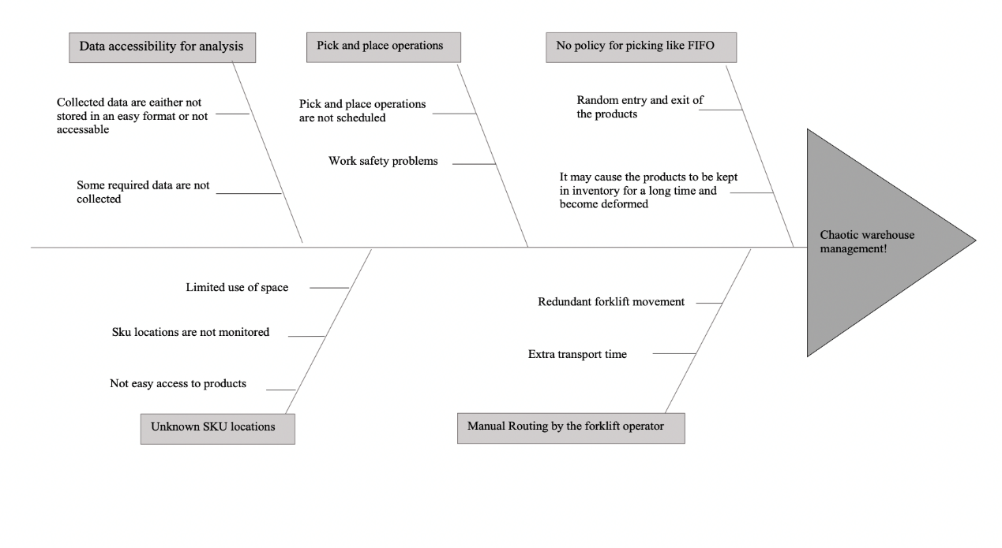

Figure 9. Fishbone Diagram

All of the diagrammed symptoms were created as a result of communication with the company and the observations made in the company. It has been reported that some required data could not be accessible in the communication established via e-mail. It was also analysed that pick and place operations are not scheduled. Forklift operations are performed manually by the operator. Besides, no policy is used like FIFO or LIFO. Specific KPIs were determined using industrial engineering methods to address the symptoms indicated for development. Toward the end of the project, Performance will be compared against the company's operations in terms of these KPIs.

* Total Forklift Distance Travelled
* Total Handling Duration
* FIFO policy utilized
* % Known locations of SKUs
* Total planning duration
* Forklift utilization

As a result, the symptoms were determined and analysed for long-term warehouse layout and management, using the solution methods of industrial engineering, and they were reduced to sub-headings. The essential solution methods were determined to eliminate the symptoms indicated in the diagram, and the problem was transformed into a mathematical model in two stages.

1. Literature Review

Considering the contributions made in this study and the scope of this subject are highly extensive, the literature review is examined under four headings including warehouse management, ABC and Pareto analyses, assignment problem, and quadratic assignment problem based on the topic discussed in the previous part above.

1. Warehouse Management

Researchers have been studying warehouse architecture and control extensively for many years since it simultaneously optimizes the existing business relationships among revenue, investment in inventory, and customer satisfaction (through service levels) as well as a company’s budget for inventory costs. As Bragg states that the area needed for item allocation and the time needed for their processing are the two primary factors that determine how well a warehouse performs (2013). In this paper, the optimization is considered based on two criteria: the reduction of travel distance and time consumption, in other words, the emphasis is developing the advantage algorithm to choose the placement of the storage and the planning of the route.

The efficiency of warehouse management is impacted by four key factors: travel, search, pick, and place. Different picking, storing, and routing rules are applied to the current system, and the results are examined by Petersen and Aase (2003). The performance of volume-based storage and random storage are compared, along with the effects of trip speed and picking rates on routing and storage policy performance, by Petersen (1999) with the best routing method created by Ratliff and Rosenthal (1983). Routing and storage policies are contrasted in this process based on the total time needed to complete a given pick list, which takes into account travel time, time spent identifying the storage location and product, time spent selecting the right quantity from the pick location, time spent verifying the pick on the pick list, and time spent loading the items into the pick cart.

The warehouse layout has a distinct impact on minimizing travel distance. Caron et al establish the association between warehouse layout and picking travel routes and show that the layout design affects the total travel distance by more than 60%. Therefore, this review continues with analyses to decide the optimal way to place the items into the shelves explained below.

1. ABC and Pareto Analyses

Almost all warehouse performance measures, such as order-picking time and cost, productivity, shipping and inventory correctness, and storage density, are influenced by the assignment of storage locations. In order to create the ideal inventory allocation system, different inventory products should be sorted into categories according to the proper standards and criteria. The classification of inventory has been done using a variety of models and approaches, with the ABC analysis approach being one of the most popular and frequently utilized for planning and inventory control (Kilgour & et al 2006).

In this study, the improvement of ABC grouping, and inventory control decisions are used to establish an optimization model. The technique is based on the Pareto analysis, which was developed by an economist in the 17th century (Nyman,2001). Pareto’s law proved that most things that are done are not critical. He stated that 20% of the products in inventory are involved in 80% of the usage actually.

In order to improve inventory control considering these parameters, recent research has been conducted on inventory classification based on the ABC approach. Since they can have thousands of goods in their inventory that need warehouse picking, even small build businesses commonly use the ABC analysis (Wan Lung, 2007). We saw that most of the classification models in the literature use the ABC inventory categorization as a ranking problem. As an illustration, a group of inventory items that are ranked in decreasing order of scores is those that are weighted according to their effectiveness. The issue of identifying the ABC inventory list as an allocation problem was considered by Douissa and Jabeur (2016). They grouped the stock items with other items that shared the most similarities in properties.

Vilfredo Pareto, an Italian economist who established a theory of unequal distribution in the 19th century, inspired quality pioneer Joseph Juran to term his theory of unequal distribution the Pareto Principle. Pareto stated that 20% of the population in the region he examined owned 80% of the wealth. It appears that many circumstances fit the 80-20 rule, or a ratio fairly close to it.

1. Assignment Problem:

The assignment problem is a sort of optimization problem that entails determining the best way to allocate a given set of resources to a given set of activities to minimize the total cost or amount of time needed. The problem is typically formulated as a collection of n jobs and a set of m resources, where each task-resource pair has a cost or time associated with it. The objective is to find a task assignment that minimizes the overall cost or time.

General transportation problems led to further extension of this approach. In 1890, Carl Gustav Jacobi revealed his solution to the assignment problem. Thompson presented another work in that area which is a non-simplex and polynomially bounded recursive approach to addressing assignment problems (1981). This methodology takes a systematic approach by examining each row individually before moving on until the best solution is found in each of the rows.

The Hungarian method, the auction algorithm, and the proposed method are just a few of the heuristics and algorithms that have been created to address the assignment problem. These algorithms search iteratively for the best task and resource matching until a result is obtained that satisfies the required standards. The famous German mathematician Konig introduced the Hungarian approach for addressing assignment problems which is one of the effective techniques for locating the best solution without a direct reference (1931). Opportunity costs highlight the relative disadvantages of allocating resources to tasks as opposed to determining the most appropriate or insignificant cost allocation. He said that it will be able to create an optimal assignment where the opportunity cost is zero if we can minimize the cost matrix to the point where there is at least one zero in each row and each column.

1. Quadric Assignment Problem:

A mathematical optimization problem known as the quadratic assignment problem aims to determine the best placement of items so that the total distances between each object and its designated location are reduced to a minimum. This issue can be represented as a mathematical equation with the objects and their designated places serving as the variables. This strategy can assist us in increasing the efficacy and efficiency of our warehouse management operations, which will ultimately result in more positive and useful outcomes for our project.

The QAP is one of the most challenging problems in combinatorial optimization, and it is well-known and extensively researched. The quadratic form of the objective function and the combinatorial structure of the QAP make it difficult to even find an approximate solution to the QAP ([Sahni & Gonzalez, 1976](https://www.sciencedirect.com/science/article/pii/S0377221720309814#bib0091)). By performing specific mathematical operations on the initial equation, the quadratic assignment problem can be converted into an assignment problem. In this procedure, the equation is made simpler by eliminating the quadratic terms, and the ideal values of the variables are determined.

[Koopmans and Beckmann (1957)](https://www.sciencedirect.com/science/article/pii/S0377221720309814" \l "bib0057) first proposed the Quadratic Assignment Problem (QAP), which entails minimizing a cost function represented by the flow and distance between each pair of facilities assigned to a particular location.

Mathematicians Li and Smith (1995) present another work in traffic circulation systems using stochastic congestion. Eventually developed an algorithm for Quadratic Assignment Problems. This is a heuristic algorithm used for solving complex problems in this field. The alternative of the Hungarian Method was further deduced by Ji (1997) based on 2n × 2n matrix levels wherein operation is performed till an optimal solution.

This part of the report provides us an important insight before proceeding to the next step which is the modeling approach. It helps us to understand our problem better and see the related methods to solve.

1. Modelıng Approach

Two models have been created by the Totomak company to solve the issue of disorganized warehouse management. The first model, which is tactical in level, deals with the six-month shelf allocation in accordance with the demand list of the company. This goal of this model is minimized total handling duration caused by product placement over the specified time period. The second model, which is situated at the operational level, aims to reduce the number of forklift sorties and the overall distance travelled during routine pick-up and placement tasks. These models were created with the intention of improving warehouse productivity and streamlining logistical processes.

The essential parameters for the models, turnover, safety stock, and maximum available to promise (ATP), have been determined. The process of parameter creation is elaborated upon below.

**Parameters of Model l**

The six-month demand list for Totomak company starting from May has been compiled.

Table III.

Number of Products

|  |  |  |  |  |  |  |  |
| --- | --- | --- | --- | --- | --- | --- | --- |
| **Demand: Weeks (Number Of Products)** | | | | | | | |
| Item | 12.05.2023 | 19.05.2023 | 26.05.2023 | 2.06.2023 | 9.06.2023 | 16.06.2023 | . . . |
| X2 | 12 | 47 | 24 | - | 36 | - | . . . |
| X3 | 24 | 12 | 36 | 12 | 12 | - | . . . |
| X4 | 12 | 12 | 12 | 36 | 12 | 12 | . . . |

The table displays the number of products that can fit on a single pallet.

Table IV.

Number of Products on a Sıngle Pallet

|  |  |
| --- | --- |
| **Item** | **Number of Product / Pallet** |
| X2 | 6 |
| X3 | 12 |
| X4 | 4 |

The table, which is based on a product-by-product analysis, has been updated to reflect the number of each product that can fit on a single pallet, resulting in the creation of a pallet-based table.

Table V.

Number of Pallets

|  |  |  |  |  |  |  |  |
| --- | --- | --- | --- | --- | --- | --- | --- |
| **Demand: Weeks (Number Of Pallets)** | | | | | | | |
| Item | 12.05.2023 | 19.05.2023 | 26.05.2023 | 2.06.2023 | 9.06.2023 | 16.06.2023 | . . . |
| X2 | 2 | 8 | 4 | - | 6 | - | . . . |
| X3 | 2 | 1 | 3 | 1 | 1 | - | . . . |
| X4 | 3 | 3 | 3 | 9 | 3 | 3 | . . . |

For each product, the week with the highest demand has been identified and added to the safety stock amount, resulting in the determination of the maximum available to promise (Max ATP) quantity. Once the total demand for each product has been determined, the frequency of turnover can be obtained by dividing it by the Max ATP value.

Table VI.

Total Demand for Each Product

|  |  |  |  |  |  |
| --- | --- | --- | --- | --- | --- |
| **Item** | **Max Weekly Demand** | **Safety Stock** | **Max ATP** | **Total Demand** | **Turnover** |
| X2 | 8 | 2 | 10 | 20 | 2 |
| X3 | 3 | 1 | 4 | 8 | 2 |
| X4 | 9 | 3 | 12 | 24 | 2 |

In order to allocate shelves, Totomak company conducted shelf measurements in their warehouse, and a distance matrix was created based on the distances between the base point and the beginning of each shelf, accounting for the distance from the base point to the location start point.

tasarım içeren bir resim

Açıklama otomatik olarak düşük güvenilirlik düzeyiyle oluşturuldu

B

A

2.9 M

1.4 M

0.9 M

Distance between A and B is 18m

taşımak, nakletmek, tekerlek, araba lastiği, taşıt, araç içeren bir resim

Açıklama otomatik olarak oluşturuldu

Figure 10. Distance Between the beginning of each Shelf

**Sets

$S$ $Stock Keeping Unit s∈S=\{1,2,…..,\left|S\right|\}$



$l$ $Location: l∈L=\{1,2.…...|L|\}$

__________________________________________________________________**

**Parameters**

$t_{s}$ $Frequency of turnover$

$a(s)$ $Number of locations to be reserve$ d for SKU's

$d_{l}$ $Distance between the base and the location l wrt forklift movements$

**Decision Variable**

$x_{l}^{s}$ $Whether location l is reserved for SKU s$

$$Min\sum_{l}{\sum_{s}{t_{s}.d_{l}.x_{l}^{s} (1)}}$$

Subject to:

$\sum_{l}{x_{l}^{s}}=a\left(s\right) ∀ s (2)$

$$\sum_{l}{x_{l}^{s}}≤ 1 ∀ l (3)$$

$x_{l}^{s} ∈\left\{0,1\right\} ∀ s, l$ (4)

To solve model 1 in the Python application, three different methods were attempted. The first method involved solving the mathematical model formulation using a general problem solver (GPS). The second method utilized a heuristic approach. The heuristic solution involved sorting items in descending order of turnover values and cloning items according to their ATP values. Next, locations were sorted in ascending order of distances. The final step was to match the minimum distance with the cloned item that had the maximum turnover. Lastly, the problem was solved using the Hungarian method. All three methods were tested on a toy problem consisting of 10 products,All codes were executed on Acer nitro i7 9th generation 16gb ram and based on the conducted experiments, pandas, scipy, numpy libraries are used in python code. The results are shown in the following table.



Figure 11. Comparison of Methods for Model 1

Both GPS and the Hungarian method were found to produce optimal results for the toy problem consisting of 10 items, but the Hungarian method was observed to be faster. The heuristic method, while producing results faster than GPS, failed to find the optimal solution. As a result, the Hungarian method was chosen for solving the problem at the actual scale.

After creating the distance and location matrices, a distance matrix was constructed for all products to solve the problem as an assignment problem. Each product was cloned as many as its Max ATP value. The distances between locations were multiplied by the turnover value of each product to obtain the distance matrix for all products and their respective locations. To solve the assignment problem, a square matrix is required. If the matrix is not square, dummies must be added.

Table VII.

xxx



The problem was solved using the Hungarian method on a Python application. The pandas, scipy, and numpy libraries were used to solve the problem. The results are presented in a summarized format.

Product 1 is assigned to shelf 1043 with a distance of 279.157  
Product 2 is assigned to shelf 490 with a distance of 283.894  
Product 3 is assigned to shelf 1099 with a distance of 281.052  
Product 4 is assigned to shelf 501 with a distance of 281.052  
Product 5 is assigned to shelf 455 with a distance of 280.736

.

.

.  
Product 1312 is assigned to shelf 965 with a distance of 282.540

Total Distance:338515.086

**Parameters of Model 2**

**Sets

$S Stock keeping units s∈S$__________________________________________________________________**

={1,2.…...|S|}

**Parameters**

$$l_{\left(i\right)} Distance of location of the item i$$

$$d_{0,l_{\left(j\right)} }Distance between the starting poing and placing product j$$

$$d_{l_{\left(i\right),0} } Distance between the picking product i and turning to the starting point$$

$$d_{l_{\left(i\right),}l_{\left(j\right),} } Distance between the picking product i and turning to the starting point$$

**Decision Variables**

$$x_{i}^{k} 1, SKU i is picked in sortie k;0 otherwise$$

$y_{i}^{k} 1, SKU i is placed in sortie k;0 otherwise$

$$z_{k} 1, if job is done in sortie k$$

$$\left(\sum_{j}{d_{0,l_{\left(j\right)}}}+ \sum_{i}{d_{l_{\left(i\right),0}}}\right)+min\sum_{i}{\sum_{j}{d_{l_{\left(i\right),}l_{\left(j\right)}}.x_{ij}}} (1)$$

Subject to:

$$\sum_{i}{x_{ij}=1, ∀j} (2)$$

$$\sum_{j}{x_{ij}=1, ∀j (3)}$$

$$x_{ij}=0 or 1, ∀i,j. (4)$$

Objective function (1) Minimizes the distance that forklifts will take to pick and place the products. Constarint (2) guarantees that a product will be picked for every sortie. Constraint (3) guarantees that a product will be placed for every sortie. Range of the decision variable (4).

Prior to solving the real-life problem in Model 2 using a Python application, a toy problem was devised as a preliminary step. Toy instances: 20 items (10 picked, 10 placed) and 100 locations.

The toy problem was subjected to three solution methods: the general problem solver formulation (GPS), the Hungarian method, and the heuristic method. All codes were executed on Acer nitro i7 9th generation 16gb ram and based on the conducted experiments, pandas, scipy, numpy libraries are used in python code. The results obtained from these methods were then compared to identify the most appropriate approach. The comparative analysis is presented in the following table.



Figure 12. Comparison of Methods for Model 2

Based on the comparison results, it can be observed that both the GPS and Hungarian algorithms yield optimal solutions, while the heuristic method fails to achieve the optimal solution. Despite the heuristic method's notable speed, the Hungarian algorithm also exhibits considerable efficiency. Based on these findings, it is determined that the problem will be solved using the Hungarian algorithm.Upon completing the six-month shelf allocation for the products in Model 1, Model 2 will come into play to optimize the daily picking/placement operations of the products. After creating a list of products to be picked/placed daily, the first-in-first-out (FIFO) system is applied to select the product from the occupied locations for picking. The product that was initially placed in a location will be chosen first for picking based on the FIFO principle. For the product to be placed, one of the reserved empty locations is selected by the model in such a way that the distance is minimized, ensuring efficient placement of the product.

Table VIII.

Pıck and Place Operatıonss of Products

|  |  |  |  |  |  |
| --- | --- | --- | --- | --- | --- |
| Pıcked | Full Cells Reserved For Item | | | | |
| X62 | 44 | 33 | 43 |  |  |
| X120 | 174 | 25 | 127 | 173 |  |
| X65 | 249 | 304 |  |  |  |
| X185 | 303 | 155 | 293 | 339 | 257 |
| X110 | 384 | 256 | 292 | 200 | 246 |

|  |  |
| --- | --- |
| Picked | Selected Shelf Location For Picking |
| X62 | 44 |
| X120 | 127 |
| X65 | 249 |
| X185 | 257 |
| X110 | 384 |

|  |  |
| --- | --- |
| Placed | Randomly Selected Cells Location For Placing |
| X45 | 75 |
| X61 | 72 |
| X146 | 159 |
| X71 | 254 |
| X188 | 379 |

|  |  |  |  |  |  |
| --- | --- | --- | --- | --- | --- |
| Placed | Empty Cells Reseved For Items | | | | |
| X45 | 84 | 88 | 130 | 75 |  |
| X61 | 164 | 72 | 36 |  |  |
| X146 | 23 | 69 | 124 | 159 | 217 |
| X71 | 300 | 254 | 382 | 336 | 428 |
| X188 | 379 | 471 |  |  |  |

After determining the shelves for the products to be collected/placed, a distance matrix is constructed for the products. It is essential for the matrix to be square in order to solve the assignment problem. In case the matrix is not square, dummies must be incorporated to ensure its squareness.

Table IX.

xxx

|  |  |  |  |  |  |
| --- | --- | --- | --- | --- | --- |
|  | 44 | 127 | 249 | 257 | 384 |
| 75 | 63 | 98 | 127 | 133 | 183 |
| 72 | 48 | 76 | 99 | 103 | 142 |
| 159 | 56 | 88 | 115 | 120 | 165 |
| 254 | 18 | 28 | 36 | 38 | 52 |
| 379 | 65 | 101 | 132 | 138 | 189 |

|  |  |  |  |  |
| --- | --- | --- | --- | --- |
|  | TOTOMAK'S TOUR (m) | OUR TOUR (m) | DIFFERENCE | EFFICIENCY |
| DAY 1 | 6397 | 5123 | 1274 | 19,92% |
| DAY 2 | 6167 | 4981 | 1186 | 19,23% |
| DAY 3 | 4990 | 2992 | 1998 | 40,04% |
| DAY 4 | 6615 | 4009 | 2606 | 39,40% |
| DAY 5 | 6171 | 3682 | 2489 | 40,33% |
| DAY 6 | 6893 | 5067 | 1826 | 26,49% |
| DAY 7 | 6065 | 4112 | 1953 | 32,20% |
| DAY 8 | 6778 | 6011 | 767 | 11,32% |
| DAY 9 | 4347 | 3781 | 566 | 13,02% |
| DAY 10 | 4322 | 3792 | 530 | 12,26% |
| DAY 11 | 6575 | 5137 | 1438 | 21,87% |
| DAY 12 | 7516 | 5568 | 1948 | 25,92% |
| DAY 13 | 6053 | 4843 | 1210 | 19,99% |
| DAY 14 | 4719 | 4140 | 579 | 12,27% |
| DAY 15 | 7960 | 5897 | 2063 | 25,92% |
| DAY 16 | 7982 | 7002 | 980 | 12,28% |
| DAY 17 | 3956 | 3440 | 516 | 13,04% |
| DAY 18 | 8454 | 6657 | 1797 | 21,26% |
| DAY 19 | 4877 | 4205 | 672 | 13,78% |
| DAY 20 | 4950 | 3779 | 1171 | 23,66% |
| DAY 21 | 6160 | 5177 | 983 | 15,96% |
| DAY 22 | 7144 | 5332 | 1812 | 25,36% |
| MINIMUM | 3956 | 2992 | 516 | 11,32% |
| MAXIMUM | 8454 | 7002 | 2606 | 40,33% |
| AVERAGE | 6141 | 4760 | 1380 | 22,07% |

Table X.

xxx

1. Conclusıon

This project has developed a novel model to solve ‘A Warehouse Decision Support System’ problem. The solutions for different instances used Quadratic Assignment Problems (QAP) and Assignment Problems as shown in **Figure 14** below. Middle of the semester, group members were met each other and academic advisors. Group members immediately contacted the company and the company advisors. Data was collected, and 2021-2022-2023 sales reports were taken from the company in November. ABC and Pareto analysis were created with the sales reports collected. Modeling approach were created in December. QAP was decided to use in our model, and we started to build our algorithm on this situation in the first step. After the QAP process, Assignment Problem was used in the second step. The reason for using the Assignment Problem is to simplify our equation approach. In the second semester, Group members are being planning to start fitting our models and creating models with small toy equations in January. Solution methods will be searched and determine the method of solution approach in February. Aftwerward, Project will be evolved to reach project solution development phase process in march. Python and Excel Solver will be used on this phase. Matrix of warehouse is going to be created to find to optimal minimum distance. Manhattan distances, Assignment Problem and Hungarian Method help to minimaziton calculation. Heuristic Method, Python Solver and Excel Solver is found to optimal solution, these results to be compared then the accuracy of project system will be checked.Subsequently, developing decision support models will be used in our project in April, thanks to Python and Excel Solver. Finally, implementation process is going to be started and finilaze the project in the last month of the semester. To summarize, Project has planned to advance entire system in a planned way by developing model and completing to project in line with the recommendations of our academic advisors.



Figure 13. Gantt Chart

1. references

Leong, W. Y., & Ee, J. (2012). A warehouse management system for 3 dimensional tracking and positioning. In *Applied Mechanics and Materials* (Vol. 152, pp. 1685-1690). Trans Tech Publications Ltd.

Bragg, S. M. (2013). *Inventory management*. Colorado: Accounting Tools.

Petersen, C. G., & Aase, G. (2004). A comparison of picking, storage, and routing policies in manual order picking. *International journal of production economics*, *92*(1), 11-19.

Petersen, C. G., & Schmenner, R. W. (1999). An evaluation of routing and volume‐based storage policies in an order picking operation. *Decision Sciences*, *30*(2), 481-501.

Ratliff, H. D., & Rosenthal, A. S. (1983). Order-picking in a rectangular warehouse: a solvable case of the traveling salesman problem. *Operations research*, *31*(3), 507-521.

Caron, F., Marchet, G., & Perego, A. (2000). Optimal layout in low-level picker-to-part systems. *International Journal of Production Research*, *38*(1), 101-117.

Chen, Y., Li, K. W., Levy, J., Hipel, K. W., & Kilgour, D. M. (2006, November). Rough-set multiple-criteria ABC analysis. In *International Conference on Rough Sets and Current Trends in Computing* (pp. 328-337). Springer, Berlin, Heidelberg.

Nyman, D., & Levitt, J. (2001). *Maintenance planning, scheduling, and coordination*. Industrial Press Inc..

Ng, W. L. (2007). A simple classifier for multiple criteria ABC analysis. *European Journal of Operational Research*, *177*(1), 344-353.

Douissa, M. R., & Jabeur, K. (2016). A new model for multi-criteria ABC inventory classification: PROAFTN method. *Procedia Computer Science*, *96*, 550-559.

Pareto, V. (1971). Manual of political economy.

Jacobi, C. G. (1890). De aequationum differentialum systemate non normali ad formam normalem revocando. , Vorlesungen über Dynamik von C. G. J. Jacobi nebstes fünf hinterlassenen Abhandlungen desselben, herausegegeben von A. Clesch, Berlin, Druck und Verlag von Georg Reimer, 1866, p. 550–578 et C.G.J. Jacobi's gesammelte Werke, fünfter Band, herausgegeben von K. Weierstrass, Berlin, Druck und Verlag von Georg Reimer, 1890, p. 485-513. (cf[I/67 a) et b)])

Thompson, G. L. (1981). A recursive method for solving assignment problems. In *North-Holland Mathematics Studies* (Vol. 59, pp. 319-343). North-Holland.

Konig, D. (1931). Graphok es matrixok [in Hungarian: Graphs and matrices], Mat es Fizikai Lapok 38, 116-119.

Sahni, S., & Gonzalez, T. (1976). P-complete approximation problems. *Journal of the ACM (JACM)*, *23*(3), 555-565.

Koopmans, T. C., & Beckmann, M. (1957). Assignment problems and the location of economic activities. *Econometrica: journal of the Econometric Society*, 53-76.

Li, W. J., & Smith, J. M. (1995). An algorithm for quadratic assignment problems. *European Journal of Operational Research*, *81*(1), 205-216.

Ji, P., Lee, W. B., & Li, H. (1997). A new algorithm for the assignment problem: An alternative to the Hungarian method. *Computers & operations research*, *24*(11), 1017-1023.